**Creating Class & Making Instances**

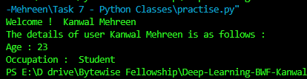

**Working With Classes & Instances**

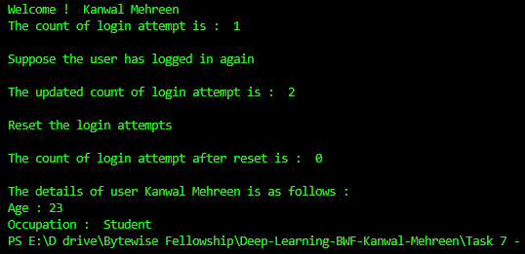

**Inheritance**

